**PCB FOOTPRINT NAMING CONVENTION**

***Preliminary Document***

**Version 0.1**

**2013/03/21**



**3rd Floor, Incubation Center Building A  
Lot D.01, Tan Thuan Road,**

**Tan Thuan Export Processing Zone  
Tan Thuan Dong Ward, District 7  
Ho Chi Minh City**

**Vietnam**

NOTICE

This document contains information of a proprietary nature. **All information contained herein shall be kept in confidence.** None of this information shall be divulged to persons other than AppliedMicro employees authorized by the nature of their duties to receive such information, or individuals of organizations authorized by AppliedMicro Corporation in accordance with existing policy regarding release of company information.

**©** Copyright AppliedMicro, All Rights Reserved

**PCB Footprint Naming Convention:**

1. Capacitors

* 1. **Array capacitor:**

1. Standard size:

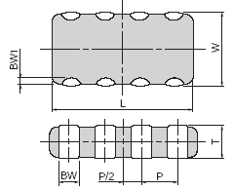

**CNn_sizename_A_LengthXWidthXHeight**

**n**: number of capacitors

**A**: I if sizename follow EIA Inch rule

M**:** if sizename follow EIA Metric rule

**Length, Width, Height**: in millimeter with 2 digit decimal

Example: CN4_0805_I_2M00X1M25X0M95

1. Other size
2. *SMT*:

**CNn_LengthXWidthXHeight**

**n**: number of capacitors

**Length, Width, Height**: in millimeter with 2 digit decimal

Example: CN8_7M40X1M50X0M80

1. *Through hole*:

**CNn_LengthXWidthXHeight** **_TH**

**n**: number of capacitors

**Length, Width, Height**: in millimeter with 2 digit decimal

Example: CN8_7M40X1M50X0M80_TH

* 1. **Polarized capacitor:**

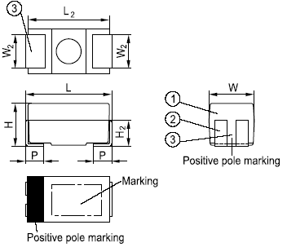

1. Standard size:

**CPsizename_A_Height**

**Height**: in millimeter with 2 digit decimal

**A**: I if sizename follow EIA Inch rule

M**:** if sizename follow EIA Metric rule

Example: CP7343_M_1M50

CP1206_I_0M70

1. Other size:
2. *SMT:*

**CP_LengthXWidthXHeight**

**Pitch,Length, Width, Height**: in millimeter with 2 digit decimal

Example: CP_7M40X1M50X1M80

1. *Through hole:*

**CP_Pitch_LengthXWidthXHeight_TH**

**CP**_**Pitch_LengthXWidthXHeight_AXIAL**

**CP**_**Pitch_DiameterXLength_RADIAL**

Pitch, Length, Width, Diameter, Height: in milimeter with 2 decimal digits

Example: CP_5M3_7M40X1M50X1M80_TH

CP_5M3_7M40X1M50X1M80_ AXIAL

CP_5M3_13M00X20M00_ RADIAL

* 1. **Unpolarized capacitor:**

1. Standard size:

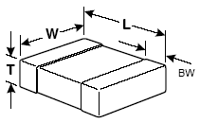

**Csizename_A_Height**

**A**: I if sizename follow EIA Inch rule

M**:** if sizename follow EIA Metric rule

**Height**: in milimeter with 2 decimal digits

Example: C7343_M_1M50

C1206_I_0M70

1. Other size
2. *SMT:*

**C_Pitch_LengthXWidthXHeight**

Pitch,Length, Width, Height: in milimeter with 2 decimal digits

Example: C_5M3_7M40X1M50X1M80

1. *Through hole:*

**C_Pitch_LengthXWidthXHeight_TH**

**C_Pitch_LengthXWidthXHeight_AXIAL**

**C_Pitch_DiameterXLength_RADIAL**

**Pitch**, **Length**, **Width**, **Diameter**, **Height**: in milimeter with 2 decimal digits

Example: C_5M3_7M40X1M50X1M80_TH

C_5M3_7M40X1M50X1M80_ AXIAL

C_5M3_13M0X20M0_ RADIAL

2. Inductors

* 1. **Array inductor:**

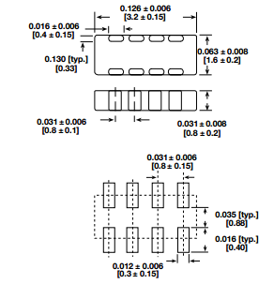

1. Standard size:

**LNn_sizename_A_LengthXWidthXHeight**

**n**: number of inductors

**Length, Width, Height**: in milimeter with 2 dec digits

**A**: I if sizename follow EIA Inch rule

M**:** if sizename follow EIA Metric rule

Example: LN4_1206_I_3M20X1M60X1M00

1. Other size
2. *SMT:*

**LNn_LengthXWidthXHeight**

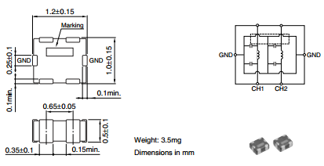

**n**: number of inductors

Length, Width, Height: in milimeter

Example: LN4_3M20X1M60X0M80

1. *Through hole:*

**LNn_LengthXWidthXHeight_TH**

**n**: number of inductors

Length, Width, Height: in milimeter

Example: LN4_3M20X1M60X0M80_TH

* 1. **Single inductor:**

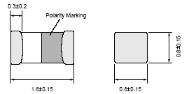

1. Standard size:

**Lsizename_A_Height**

Height: in milimeter with 2 decimal digits

**A**: I if sizename follow EIA Inch rule

M**:** if sizename follow EIA Metric rule

Example: L0603_I_0M95

L1206_I_2M00

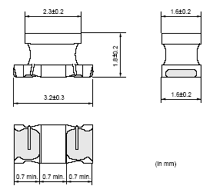

1. Other size

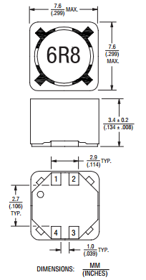

1. *SMT:*

**L_Pitch_LengthXWidthXHeight**

Pitch,Length, Width, Height: in milimeter

Example: L_5M15_7M60X7M60X3M60

1. *Through hole:*

**L_Pitch_LengthXWidthXHeight_TH**

**L_Pitch_LengthXWidthXHeight_AXIAL**

**L_Pitch_DiameterXLength_RADIAL**

Pitch, Length, Width, Diameter, Height: in milimeter

Example: L_5M3_7M40X1M50X1M80_TH

L_5M3_7M40X1M50X1M80_ AXIAL

L_5M3_13M0X20M0_ RADIAL

1. FUSE:

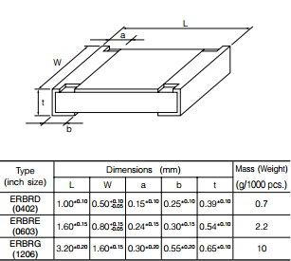

1. Standard size:

**Fsizename_A_Height**

Height: in milimeter with 2 decimal digits

**A**: I if sizename follow EIA Inch rule

M**:** if sizename follow EIA Metric rule

Example: F0603_I_0M64

1. Other size

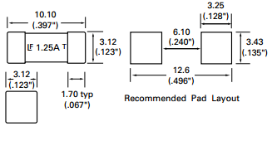

1. *SMT:*

**F_Pitch_LengthXWidthXHeight**

Pitch,Length, Width, Height: in milimeter with

Example: F_8M40_10M10X3M12X3M12

1. *Through hole:*

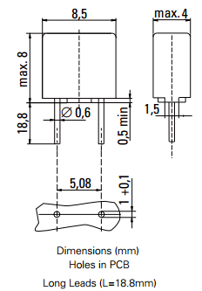

**F_Pitch_LengthXWidthXHeight_TH**

**F_Pitch_LengthXWidthXHeight_AXIAL**

**F_Pitch_DiameterXLength_RADIAL**

Pitch, Length, Width, Diameter, Height: in milimeter with 2 decimal digits

Example: F_5M08_8M50X4M00X8M00_TH

F_5M08_8M50X4M00X8M00_ AXIAL

F_5M08_8M50X4M00_ RADIAL

1. FERRITE BEAD:

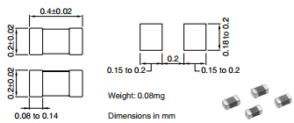

1. Standard size:

**FBsizename_A_Height**

Height: in milimeter with 2 decimal digits

**A**: I if sizename follow EIA Inch rule

M**:** if sizename follow EIA Metric rule

Example: FB0402_I_0M55

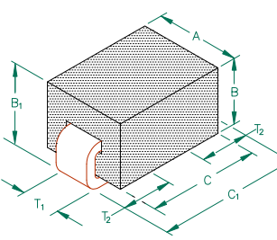

1. Other size:
2. *SMT:*

**FB_Pitch_LengthXWidthXHeight**

Pitch,Length, Width, Height: in milimeter

Example: FB_5M08_4M06X3M05X3M05

1. *Through hole:*

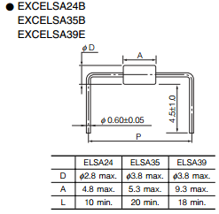

**FB_Pitch_LengthXWidthXHeight_TH**

**FB_Pitch_LengthXWidthXHeight_AXIAL**

**FB_Pitch_DiameterXLength_RADIAL**

Pitch, Length, Width, Diameter, Height: in milimeter

Example: FB_10M3_3M80X9M30X1M80_TH

FB_10M3_3M80X9M30X3M80_ AXIAL

FB_10M3_3M80X9M30_ RADIAL

1. Resistor
   1. **Array resistor:**
2. Standard size:

**RNn_sizename_A_LengthXWidthXHeight**

n: number of resistors

Length, Width, Height: in milimeter

**A**: I :if sizename follow EIA Inch rule

M**:** if sizename follow EIA Metric rule

Example: RN08_0402_I_2M00X1M00X0M55

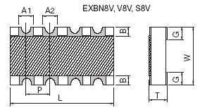

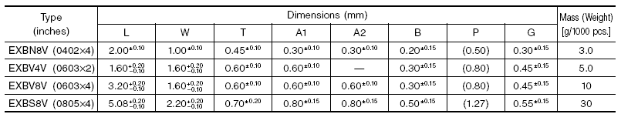

1. Other size

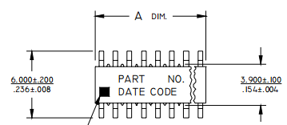

1. *SMT:*

**RNn_LengthXWidthXHeight**

n: number of resistors

Length, Width, Height: in milimeter

Example: RN14_3M60X3M90X1M75

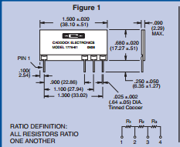

1. *Through hole:*

**RNn_LengthXWidthXHeight _TH**

n: number of inductors

Length, Width, Height: in milimeter

Example: RN3_38M10X2M29X17M27_TH

* 1. **Single resistor:**

1. Standard size:

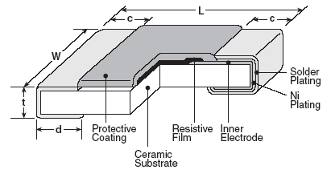

**Rsizename_A_Height**

Height: in milimeter

**A**: I if sizename follow EIA Inch rule

M**:** if sizename follow EIA Metric rule

Example: R0805_I_1M25

1. Other size
2. *SMT:*

**R_Pitch_LengthXWidthXHeight**

Pitch,Length, Width, Height: in milimeter

Example: R_5M3_7M40X1M50X1M80

1. *Through hole:*

**R_Pitch_LengthXWidthXHeight_TH**

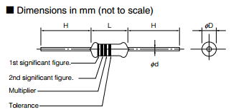

**R_Pitch_DiameterXLength_AXIAL**

**R_Pitch_DiameterXLength_RADIAL**

Pitch, Length, Width, Diameter, Height: in milimeter

Example: R_5M00_1M70X3M20X1M80_TH

R_5M00_1M70X3M20_ AXIAL

R_5M00_1M70X3M20_ RADIAL

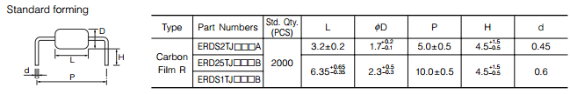

1. DIODE:
   1. Standard size:

**D_sizename_Height**

Height: in milimeter

Example: D_DO-214AC_2M62

* 1. Other size:

1. 2 pins type:
2. *SMT:*

**D_Pitch_LengthXWidthXHeight**

Pitch,Length, Width, Height: in milimeter

Example: D_5M3_7M40X1M50X1M80

1. *Through hole:*

**D_Pitch_LengthXWidthXHeight_TH**

**D_Pitch_ DiameterXLength_AXIAL**

**D_Pitch_ DiameterXLength_RADIAL**

Pitch, Length, Width, Diameter, Height: in milimeter

Example: D_5M3_7M40X1M50X1M80_TH

D_5M3_7M40X1M50_ AXIAL

D_5M3_7M40X1M50_ RADIAL

1. >2 pins type:
2. *SMT:*

**Dn_LengthXWidthXHeight**

**n**: number of pins

Length, Width, Height: in milimeter

Example: D4_7M40X1M50X0M80

1. *Through hole:*

**Dn_LengthXWidthXHeight_TH**

**n**: number of pins

Length, Width, Height: in milimeter

Example: D4_7M40X1M50X0M80_TH

1. Transistors:

* 1. Standard size:

1. *SMT:*

**Q_sizename_Height_BCE**

Height: in milimeter

Example: Q_SOT-23_1M26_BCE

1. *Through hole:*

**Q_ sizename_Height_BCE_TH**

* 1. Other size

1. *SMT:*

**Qn_LengthXWidthXHeight_BCE**

**n**: number of pins

Length, Width, Height: in milimeter

Example: Q3_5M3_7M40X1M50X1M80_BCE

1. *Through hole:*

**Qn_LengthXWidthXHeight_BCE_TH**

n: number of pins

Length, Width, Height: in milimeter

Example: Q3_5M3_7M40X1M50X1M80_BCE_TH

1. FET:

* 1. Standard size:

1. *SMT:*

**Q_sizename_Height_GDS**

Height: in milimeter

Example: Q_SOT-23_1M26_GDS

1. *Through hole:*

**Q_ sizename_Height_GDS_TH**

* 1. Other size

1. *SMT:*

**Qn_LengthXWidthXHeight_GDS**

**n**: number of pins

Length, Width, Height: in milimeter

Example: Q3_5M3_7M40X1M50X1M80_GDS

1. *Through hole:*

**Qn_LengthXWidthXHeight_GDS_TH**

n: number of pins

Length, Width, Height: in milimeter

Example: Q3_5M3_7M40X1M50X1M80_GDS_TH

1. Crystals and Oscillators:
   1. Standard size:
2. *SMT:*

**OSCn_sizename_Height**

**XTALn_sizename_ Height**

Height: in milimeter

n: number of pins

Example: XTAL4_CSM-12_2M5

OSC4_ECS-8FM_4M7

1. *Through hole:*

**OSCn_sizename_ Height _TH**

**XTALn_sizename_ Height _TH**

Height: in milimeter

n: number of pins

Example: OSC4_2-A401A _TH

* 1. Other size

1. *SMT:*

**OSCn_LengthXWidthXHeight**

**XTALn_LengthXWidthXHeight**

n: number of pins

Length, Width, Height: in milimeter

Example: OSC4_7M40X1M50X1M80

1. *Through hole:*

**OSCn_LengthXWidthXHeight_TH**

**XTALn_LengthXWidthXHeight_TH**

n: number of pins

Length, Width, Height: in milimeter

Example: OSC4_7M40X1M50X1M80_TH

1. ICs:

**Package Typen_Pitch_LengthXWidthXHeight**

n: number of pins

Pitch, Length, Width, Height: in milimeter

**Package Type**: See the table below

Example: SOIC8_1M27_5MX4MX1M75

BGA256_1M27_27MX27MX1M7

|  |  |
| --- | --- |
| **Package type** |  |
|  |  |
| **SOP** | Small Outline Package |
| **QSOP** | Quarter-size Small Outline Package |
| **TSOP** | Thin Small Outline Package |
| **SSOP** | Shrink Small Outline Package |
| **TSSOP** | Thin Shrink Small Outline Package |
| **HTSSOP/EPTSSOP** | Thin Shrink Small Outline Package with heat sink |
| **MSOP** | Mini Small Outline Plastic Packages |
| **HMSOP** | Mini Small Outline Plastic Packages with heat sink |
| **eMSOP** |  |
| **PSOP** | Power Small Outline Plastic Packages |
| **PSSOP** |  |
| **VSSOP** |  |
| **LSOP** |  |
|  |  |
| **QFP** | Quad Flat Package |
| **TQFP** | Thin Quad Flat Package |
| **LQFP** | Low Profile Quad Flat Package |
| **PQFP** | Plastic Quad Flat Package |
| **VQFP** | Very Thin Quad Flat Package |
| **MQFP** | Metric Plastic Quad Flatpack Packages |
| **CQFP** | Ceramic Quad Flatpack Package |
| **BQFP** | Bumpered Quad Flat Package |
| **FQFP** | Fine Pitch Quad Flat Package |
| **HQFP** | Heat sinked QFP |
| **SQFP** | Small Quad Flat Package |
| **RQFP** | Rectangular Plastic Gull Wing Quad Flat Pack |
|  |  |
| **PDIP** | Dual-In-Line Plastic Packages |
| **SPDIP** | Shrink Dual-In-Line Plastic Packages |
| **CerDIP** | Ceramic Dual-In-Line Frit Seal Packages |
| **SBDIP** | Ceramic Dual-In-Line Metal Seal Packages |
|  |  |
| **UTQFN** | Ultra Thin Quad Flat No-Lead COL Plastic Package |
| **TQFN** | Thin Quad Flat No-Lead Plastic Package |
|  |  |
| **MLF** | Micro Lead Frame Package |
|  |  |
| **PLCC** | Plastic Leaded Chip Carrier |
| **LCCC** | Leadless Ceramic Chip Carrier |
| **CLCC** | Ceramic Leadless Chip Carrier Packages |
| **JLCC** | Windowed, Ceramic J-leaded Chip Carrier |
|  |  |
| **SOIC** | Small Outline Integrated Circuit |
|  |  |
| **SOJ** | Small Outline J-Leaded Package |
| **WDFN** |  |
| **DFN** | Dual Flat No-Lead Plastic Package |
| **UTDFN** | Ultra Thin Dual Flat No-Lead Plastic Package |
| **ODFN** | Optical Dual Flat No-Lead Plastic Package |
| **ZIP** | Zigzag In-line Package |
| **SIP** | Single In-line Package |
| **BGA** | Ball Grid Array |
| **HBGA** | Hyper Ball Grid Array (Hyper-BGA) |
| **CBGA** | Ceramic Ball Grid Array |
| **FBGA** | Fine-Pitch Ball Grid Array |
| **FCBGA** | Flip Chip Ball Grid Array |
| **PGA** | Pin Grid Array |

1. Connector:

**CONN-Typen_Partnumber_(option: xxxx)**

**Type**: SM ( Surface Mount)

TH (Though hole)

PF (Press fit)

**n**: number of pins

Option: connector function: USB, DB9, …

Example: CONN-TH3_ MJ-3502

1. Header:

SMT: **HDRNxXNy_Pitch_LengthXWidthXHeight_Angle**

Though_hole: **HDRNxXNy_Pitch_LengthXWidthXHeight_TH_Angle**

**Nx, Ny**: number of pin in x-axis and y-axis

Pitch,Length, Width, Height: in millimeter

**Angle**: VT, RA

Example: HDR2x4_2M54_10MX4MX4M_TH_RA

1. Switch:

**SW-Typen_Partnumber**

**Type**: SM ( Surface Mount)

TH (Though hole)

**n**: number of pins

Example: SW-SM4_SDA02H0SK

1. LEDs:

* 1. Standard size:

1. *SMT:*

**LED_sizename_A_Height**

Height: in milimeter

**A**: I :if sizename follow EIA Inch rule

M**:** if sizename follow EIA Metric rule

Example: LED_0603_I_1M26

* 1. Other size:

1. *SMT:*

**LED-SMn_LengthXWidthXHeight**

**n**: number of pins

Length, Width, Height: in milimeter

Example: LED-SM4_7M40X1M50X1M80

1. *Through hole:*

**LED-THn_LengthXWidthXHeight**

**n**: number of pins

Length, Width, Height: in milimeter

Example: LED-TH4_7M40X1M50X1M80

1. Testpoint:

**TP_Type_padsize_Partnumber**

**Type**: SM ( Surface Mount)

TH (Though hole)

Padsize: padstack size (drill 10mil, circle pad 18 mil for testpoint under BGA)

Example: TP_SM_ 5015

TP _TH_D010C020